Question: Consider an application to be developed for various size devices like desktop, tablet, mobile.  And the company wants to test with the POC (Proof Of Concept), below are the requirements.

Considering the application is loaded on desktop with size 786\*600px the page should load the text with Arial, 36pt, Blue Color.

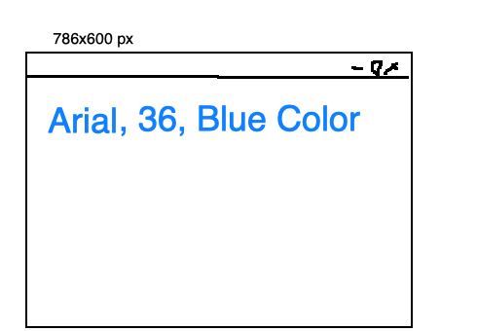

When the page is loaded with 300x350 px then the fonts to be Helvetica, 24pt,, and in Red Color.



And when the screen size happens to be 100x100 then font Courier, 18pt, Purple color.



Note: Preferable don’t use any library. Good to have smoot finishing.